|  |  |  |
| --- | --- | --- |
| **Name:**  **Sumukh Raju Bhat** | **SRN: PES1UG19CS519** | **Section H** |
| **Date: 10/3/2022** | **Week Number:05** |

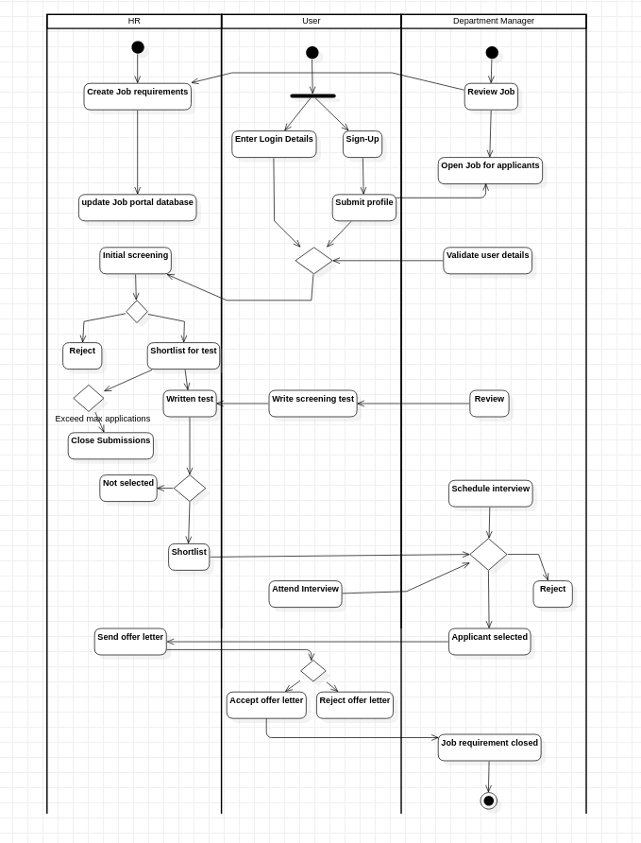

**2.**